**لون حسب الأرقام:**

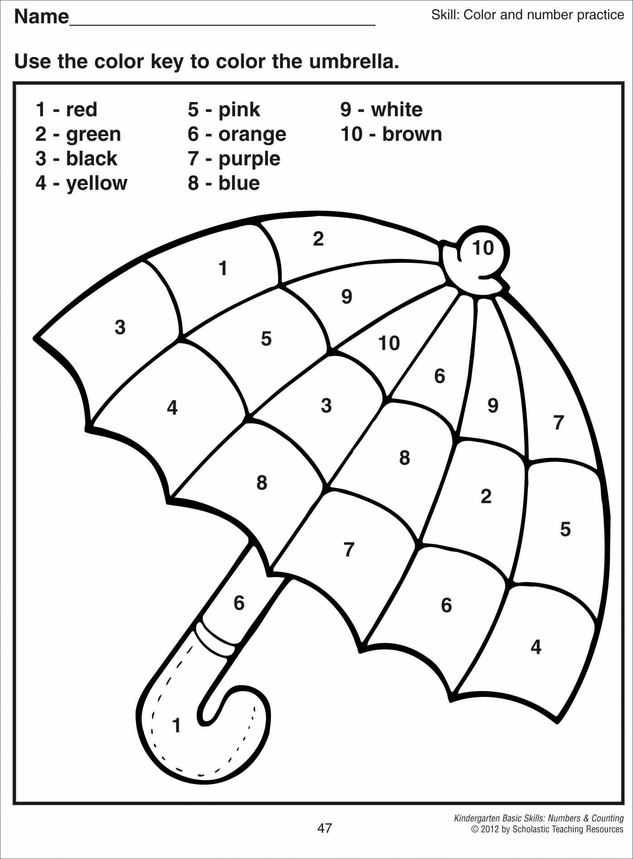**لون:**

[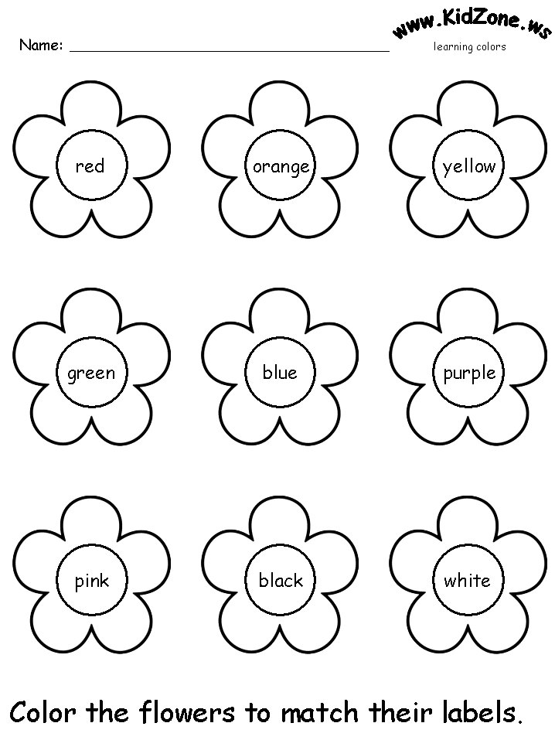](https://www.google.com/url?sa=i&url=https://www.pinterest.com/pin/262334747018799837/&psig=AOvVaw3V8kCx2IjSbSpWxGnfbH8h&ust=1583183253334000&source=images&cd=vfe&ved=0CAIQjRxqFwoTCOjN3K6X-ucCFQAAAAAdAAAAABBD)