**أسمي: ______ التاريخ:______ الصف: ________**

**مد خطاً بين الحرف الكبير والصغير الملائم له:**

**[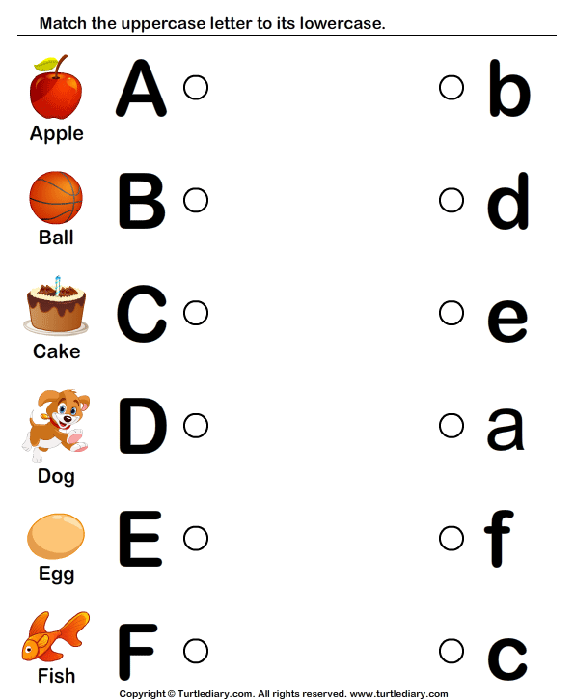](https://www.google.com/url?sa=i&url=https://www.pinterest.com/pin/193091902751290562/&psig=AOvVaw0e21ji-yRqJvZw5ybKF6vV&ust=1583169771948000&source=images&cd=vfe&ved=0CAIQjRxqFwoTCPjWnpDl-ecCFQAAAAAdAAAAABAI)**

[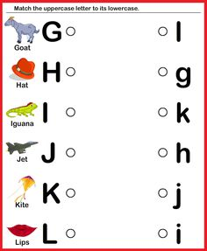](https://www.google.com/url?sa=i&url=https://www.pinterest.com/omombmscbe685/&psig=AOvVaw0e21ji-yRqJvZw5ybKF6vV&ust=1583169771948000&source=images&cd=vfe&ved=0CAIQjRxqFwoTCPjWnpDl-ecCFQAAAAAdAAAAABA8)

[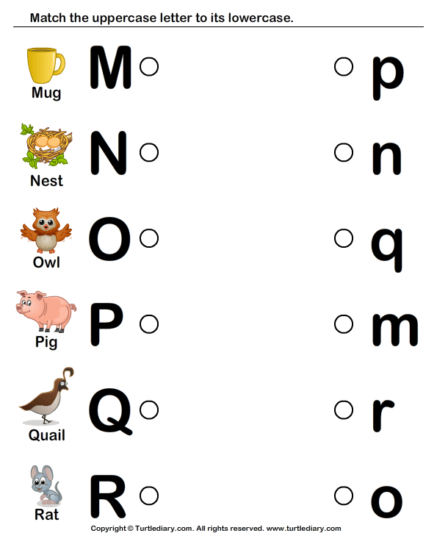](https://www.google.com/url?sa=i&url=https://www.turtlediary.com/worksheet/draw-line-to-match-letters-m-to-r.html&psig=AOvVaw0e21ji-yRqJvZw5ybKF6vV&ust=1583169771948000&source=images&cd=vfe&ved=0CAIQjRxqFwoTCPjWnpDl-ecCFQAAAAAdAAAAABAn)

[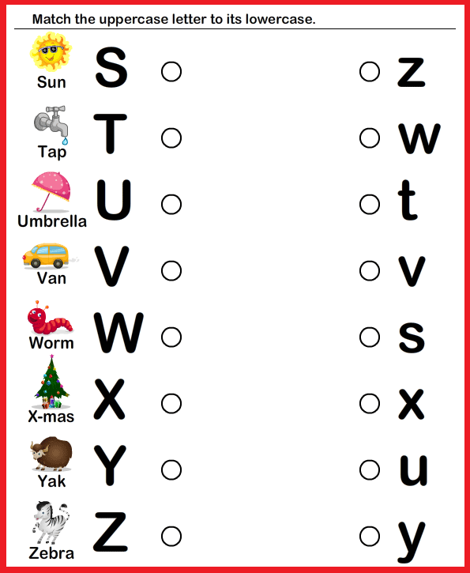](https://www.google.com/url?sa=i&url=https://www.pinterest.com/pin/430093833157958846/&psig=AOvVaw0e21ji-yRqJvZw5ybKF6vV&ust=1583169771948000&source=images&cd=vfe&ved=0CAIQjRxqFwoTCPjWnpDl-ecCFQAAAAAdAAAAABAu)

**ضع دائرة حول الحرف الصغير الملائم:**

[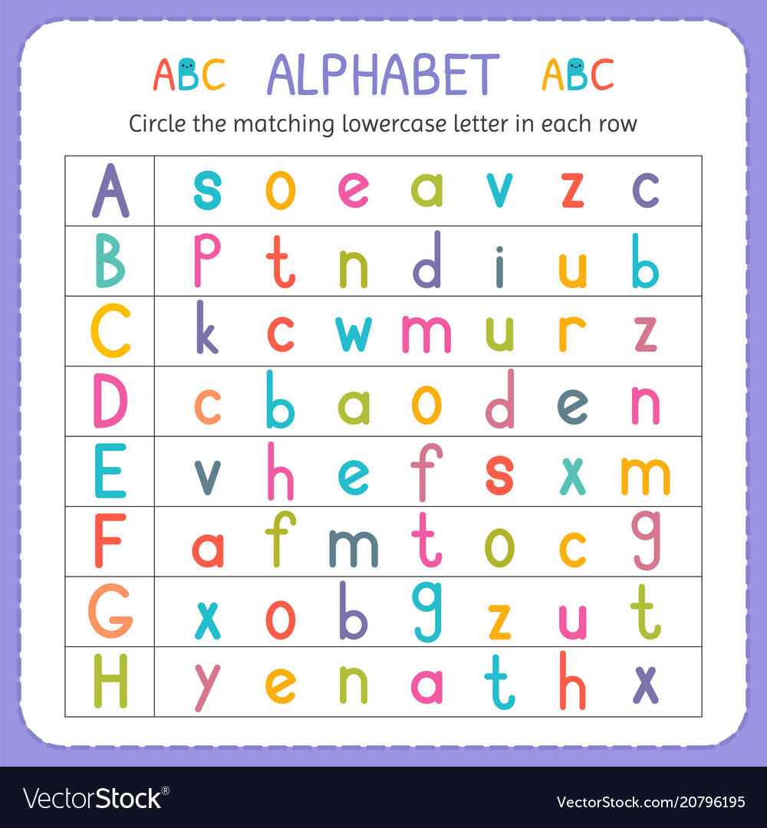](https://www.google.com/url?sa=i&url=https://www.vectorstock.com/royalty-free-vector/circle-the-matching-lowercase-letter-in-each-row-vector-20796195&psig=AOvVaw0e21ji-yRqJvZw5ybKF6vV&ust=1583169771948000&source=images&cd=vfe&ved=0CAIQjRxqFwoTCPjWnpDl-ecCFQAAAAAdAAAAABAO)

[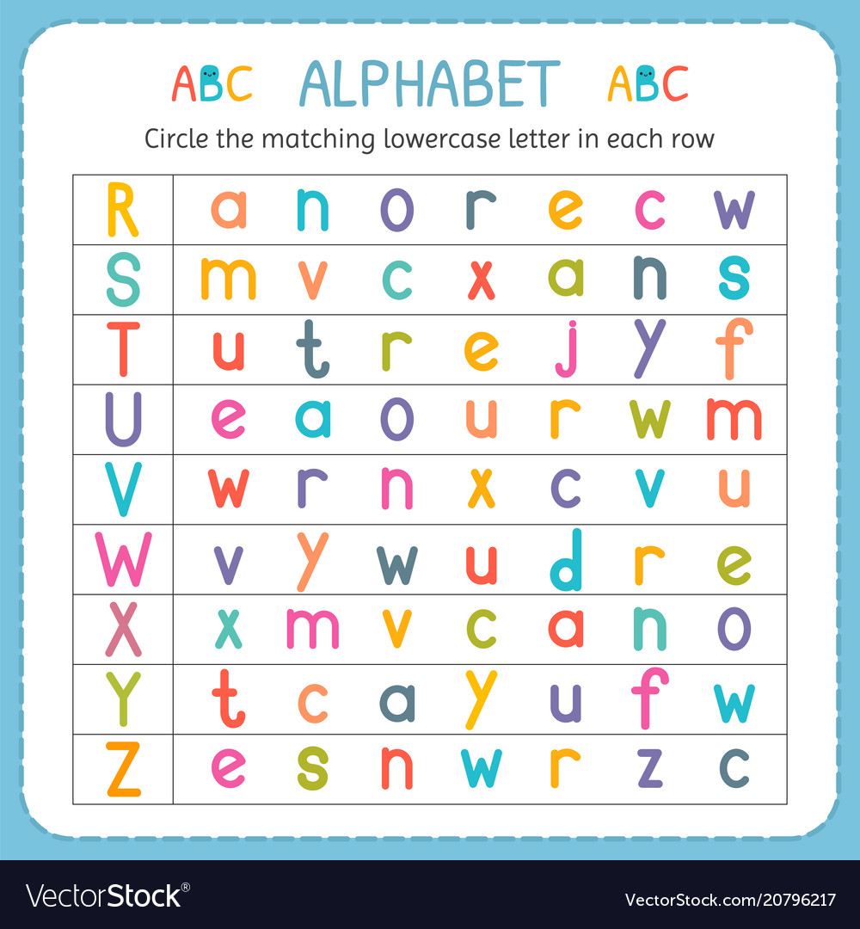](https://www.google.com/url?sa=i&url=https://www.vectorstock.com/royalty-free-vector/circle-the-matching-lowercase-letter-in-each-row-vector-20796217&psig=AOvVaw0e21ji-yRqJvZw5ybKF6vV&ust=1583169771948000&source=images&cd=vfe&ved=0CAIQjRxqFwoTCPjWnpDl-ecCFQAAAAAdAAAAABAU)

**أكمل الابجدية بالأحرف الصغيرة فقط:**

[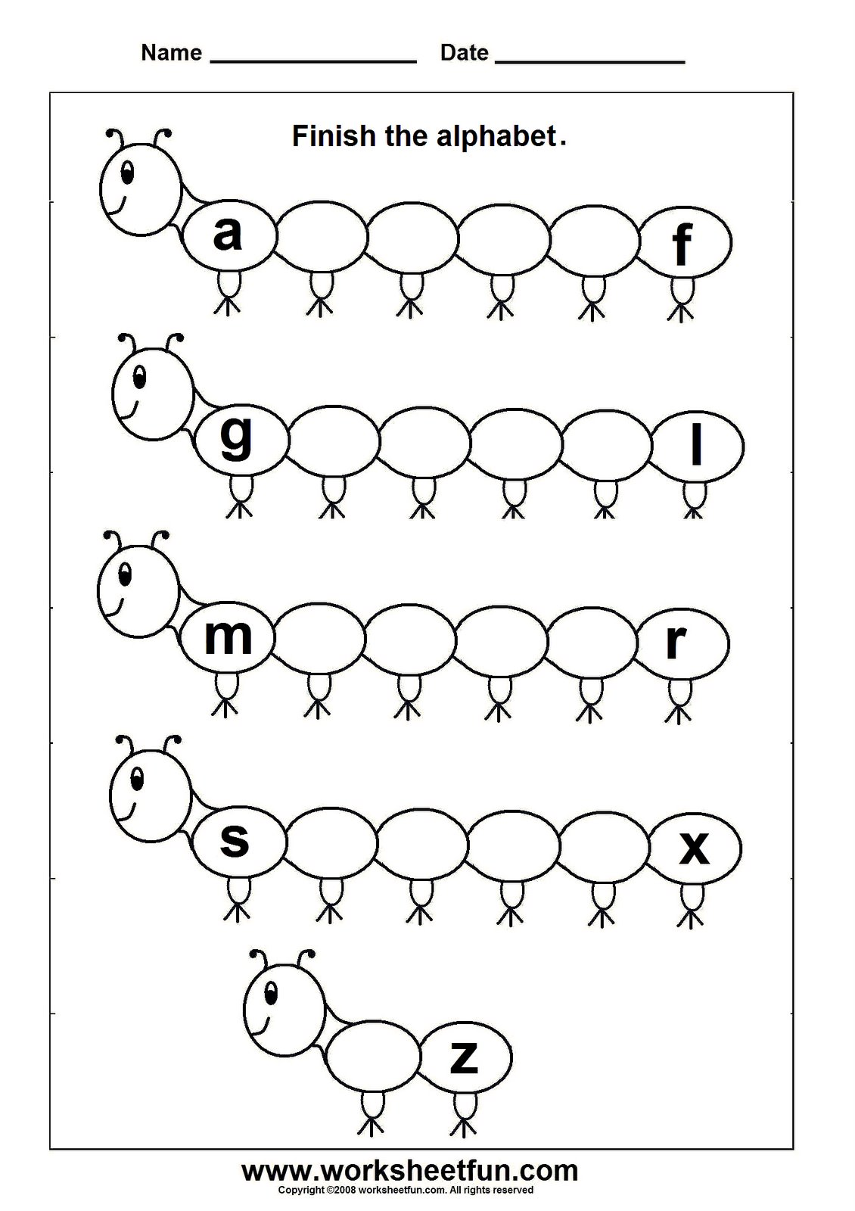](https://www.google.com/url?sa=i&url=http://securidoor.org/index.php/home-work/23580/&psig=AOvVaw21N4ihHUqZVWJ9_gu5k0ky&ust=1583171305244000&source=images&cd=vfe&ved=0CAIQjRxqFwoTCMDZ0fjq-ecCFQAAAAAdAAAAABBP)

**لائم:**

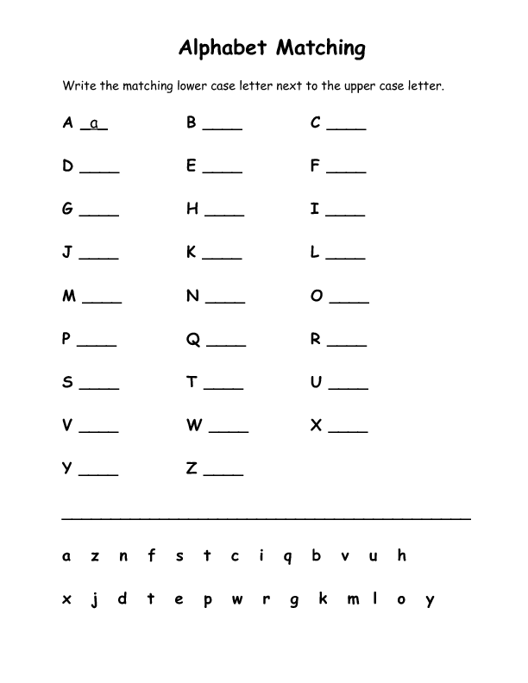

[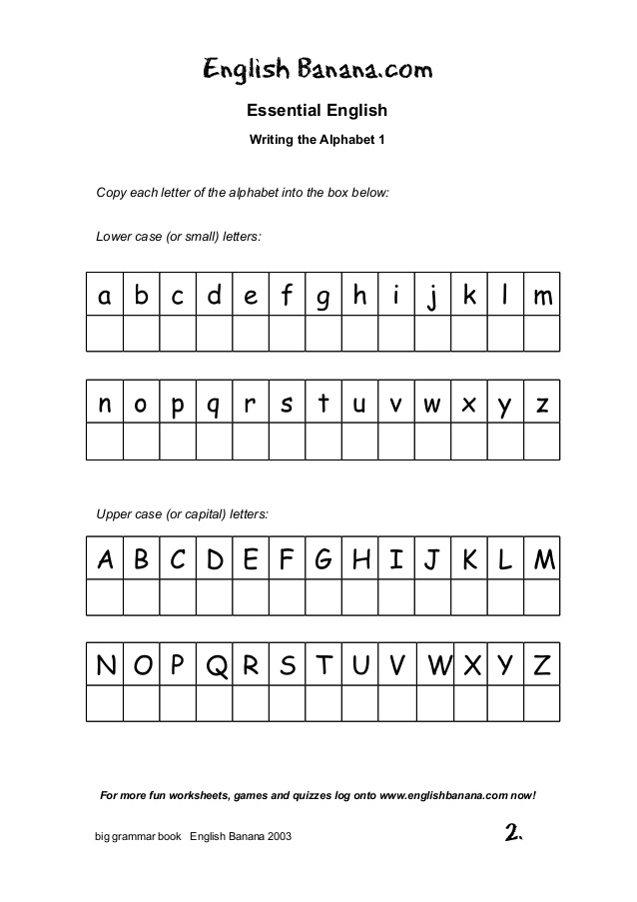](https://www.google.com/url?sa=i&url=https://www.slideshare.net/gaby_rm2004/1-biggrammarbook-46205360&psig=AOvVaw21N4ihHUqZVWJ9_gu5k0ky&ust=1583171305244000&source=images&cd=vfe&ved=0CAIQjRxqFwoTCMDZ0fjq-ecCFQAAAAAdAAAAABBg)**حول الحروف الصغيرة الى كبيرة، والكبيرة الى صغيرة:**

[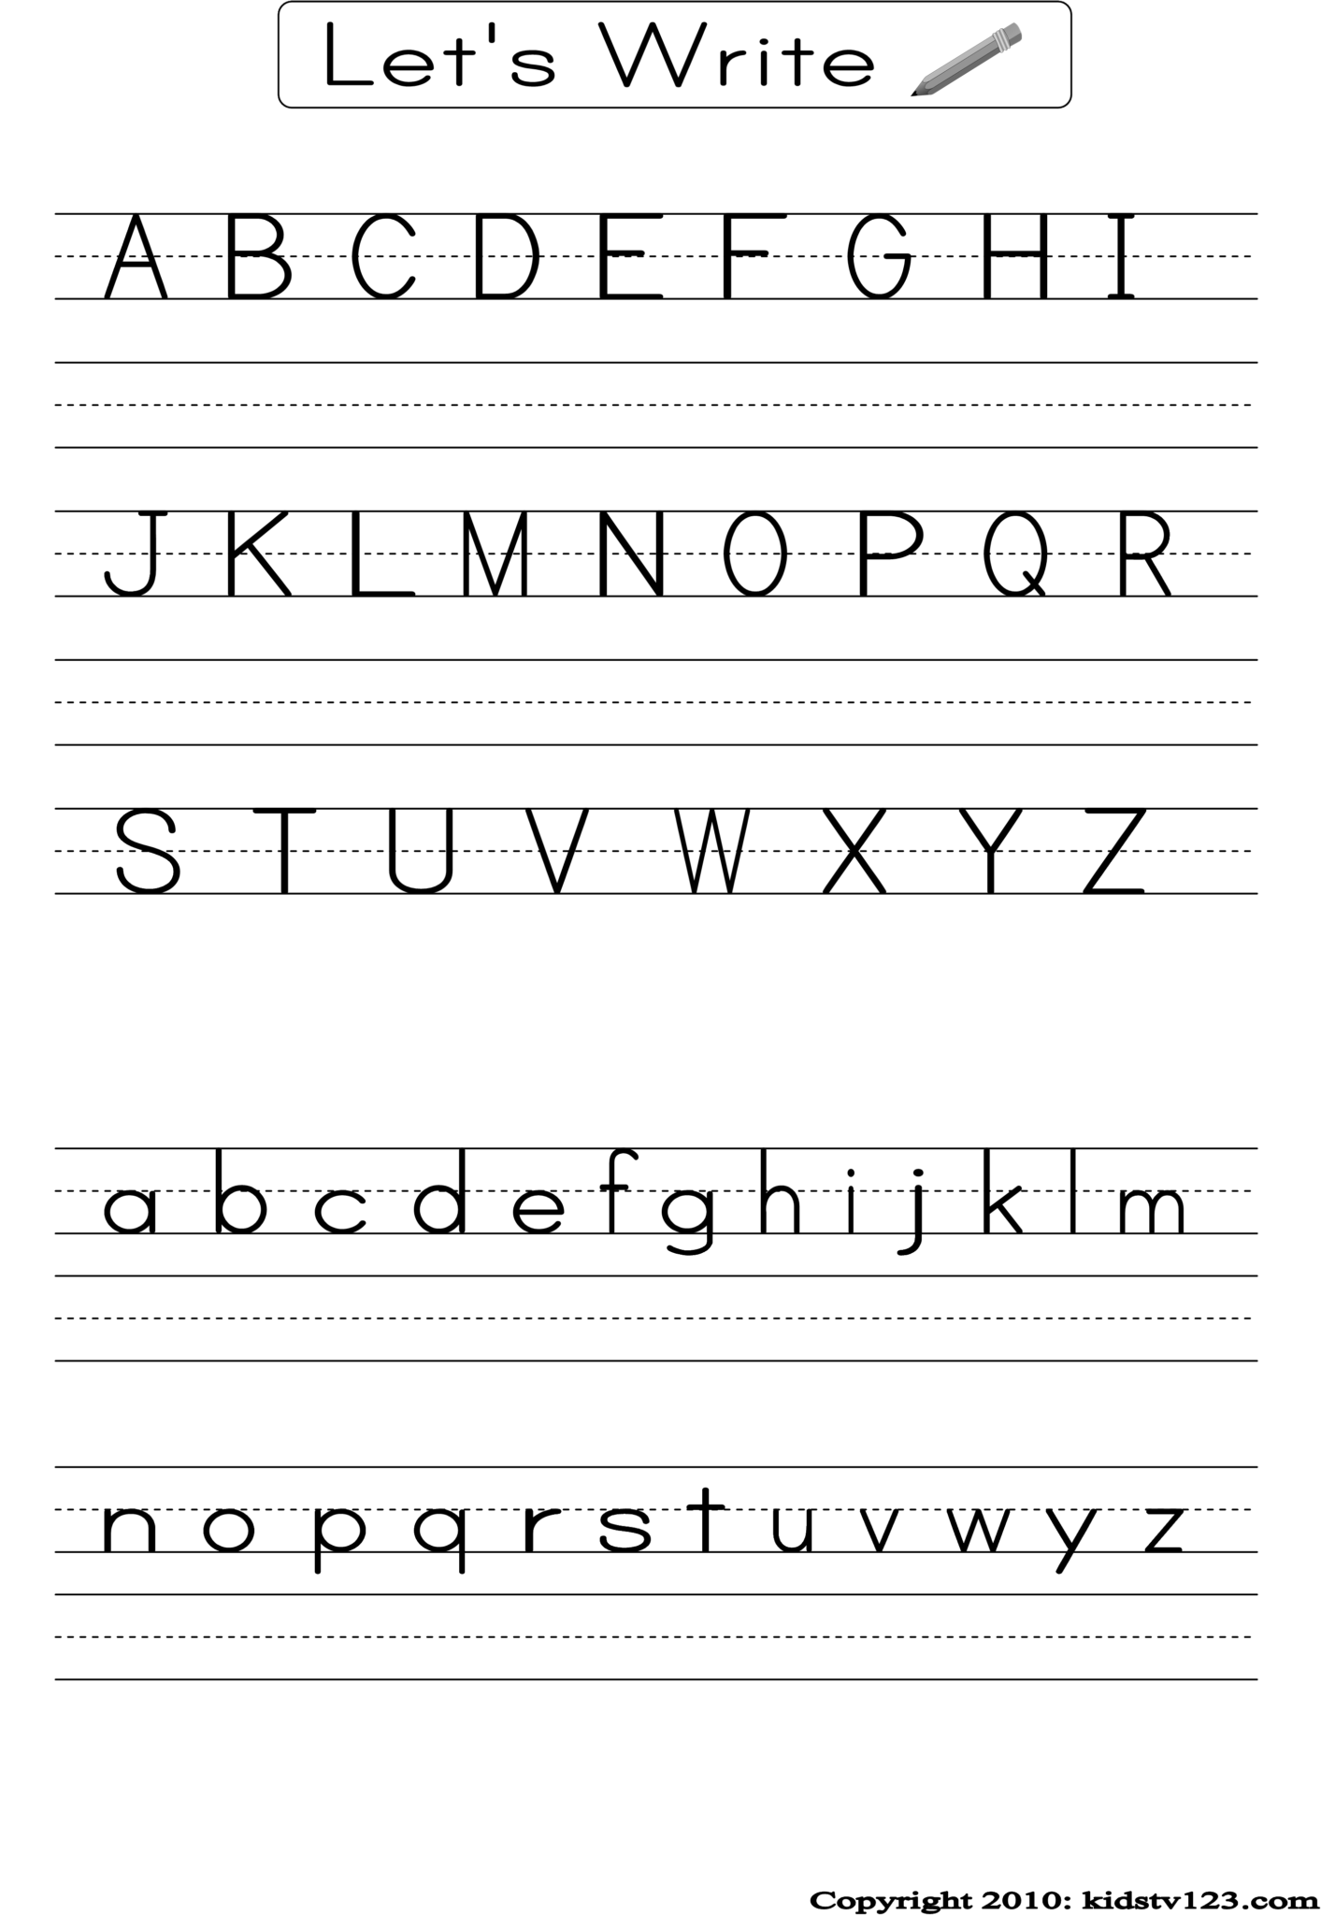](https://www.lovingprintable.com/writing-abc-for-tidy-handwriting/writing-abc-printable/)**انسخ بخط جميل:**